FOR IMMEDIATE RELEASE

Jack Hanley Gallery, San Francisco

David Godbold
May 5 – 27, 2006
Opening reception: Friday, May 5th, 6-9pm

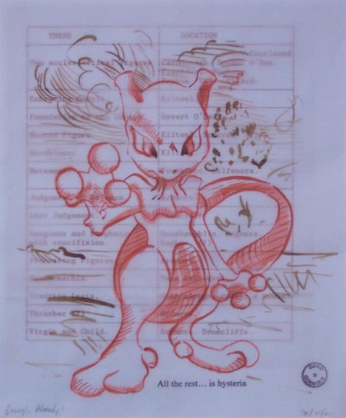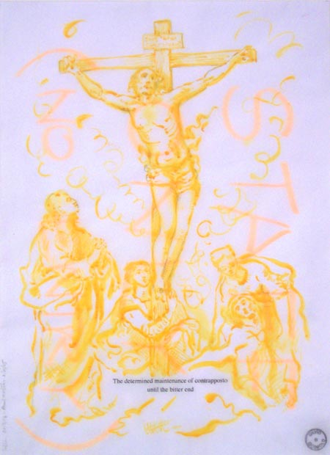

The Jack Hanley Gallery, San Francisco is pleased to present the first West Coast solo exhibition of Dublin-based artist David Godbold. The exhibit will feature Godbold’s works on paper and found materials (such as discarded printed matter, old tickets, leaflets and receipts) as well as a large wall painting.

Through his use of ink on semi translucent materials and his 16th century-esque draftsmanship, Godbold’s works very closely resemble those of the Renaissance and Baroque eras. While his subject matter, as well, often references the religious fervor of these periods in the history of art, Godbold also incorporates pop cultural iconography, such as the likes of Tin Tin or Pokemon while still maintaining his old master drawing style. Through the effects of layering his hand-drawn images on the detritus of daily life, receipts, shopping lists, and accompanying these layers with a word-processed caption, Godbold furthers the arbitrary and ironic relationships between subject and object. As Jon Thompson mentions in his essay on Godbold’s work, this simultaneity of historical and cultural moments “opens on to an infinity of disconnections and uncertainties, the far gone end of which will remain forever beyond our grasp.”
David Godbold has exhibited widely and has had solo shows in Ireland, Britain, Italy, France and Australia. He participated in the highly acclaimed 'Clockworks' - a PS1/MoMA International Studio Programme Exhibition at The Clocktower Gallery, New York, in 2000 and the residency at the British School in Rome, 2002. He is represented in the collections of Trinity College, Dublin, the Irish Museum of Modern Art and in many private and corporate collections throughout Europe, Australia and the USA.

For more information or images, please contact Ava Jancar at: (415)522-1623,
or visit our website at: www.jackhanley.com.

