FOR IMMEDIATE RELEASE

David Sherry
395 Valencia Street
February 3 – 28th, 2005
Opening reception, Thursday, February 3rd, 6-9pm
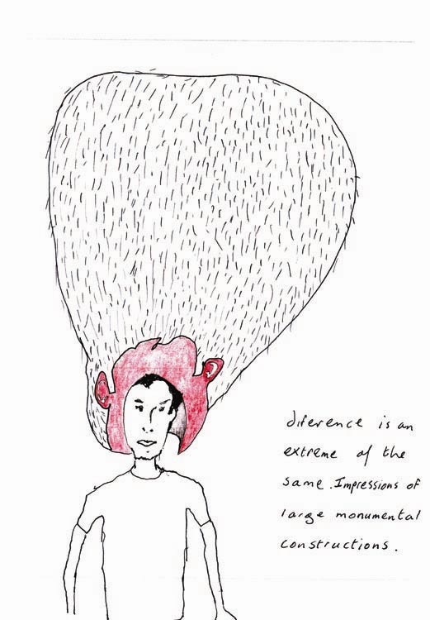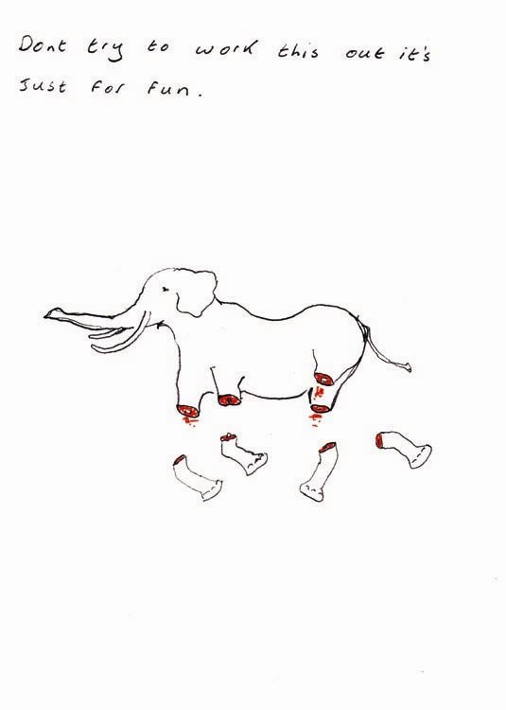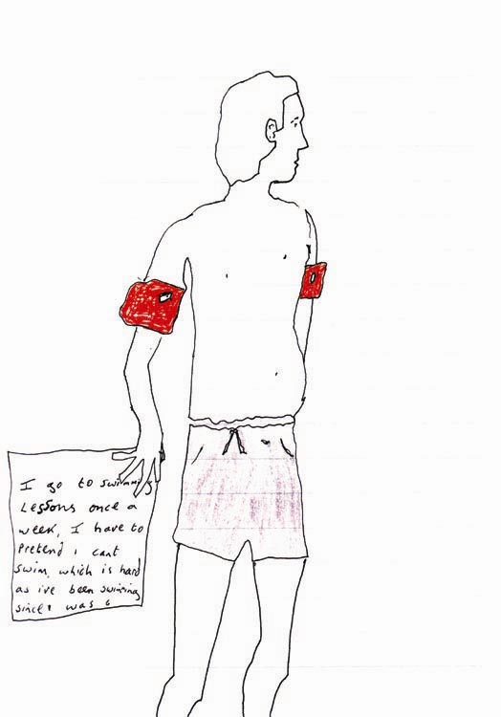

Jack Hanley Gallery is pleased to present the first American solo show of Glasgow-based artist David Sherry. The exhibition will include sound, video, and three-dimensional pieces in addition to works on paper.

David Sherry is known for his long-term performative pieces which will sometimes continue over a period of days. With an ulterior motive in mind his absurd gestures allow the artist time to address the routines and rituals played out in everyday life. ‘Carrying a bucket of water about for a week’ and ‘Avoiding eye contact for one seven day period’, for example, are self imposed ‘instructions’ which add perspective to his otherwise normal daily life. The artist describes these acts as ‘air photography for thought’.

Sherry’s ability to take this birds eye view on society, swoop down and pick bits up to chew on and regurgitate back down on the unexpected crowds, is central to his work. In an earlier video entitled, ‘Sun’s F***ed’, for example, Sherry presents a straight-faced monologue proposing the replacement of the sun with a minimalist Italian-designed lighting unit. In 2000, Sherry developed a campaign for Tom Cruise’s hair after he noticed that this famous mop had become an independent state gaining control and power. In a bid to inform the public of this incredible development Sherry took to the streets with a sign and began to canvas in support of the hair.

In 2003, Sherry was short listed for the Beck's Futures prize. David Sherry has had solo shows in 2004 at the Gallery of Modern Art Glasgow and at the Collective Gallery and Tramway (Glasgow) in 2003.

For further information or press images please contact Ava Jancar at 415.522.1623 or visit our website: www.jackhanley.com.

