December 8, 2005

FOR IMMEDIATE RELEASE:

Saskia Leek: Points of Vanishing
Jack Hanley Gallery, San Francisco
Opening Reception: Saturday, December 17, 6-9pm

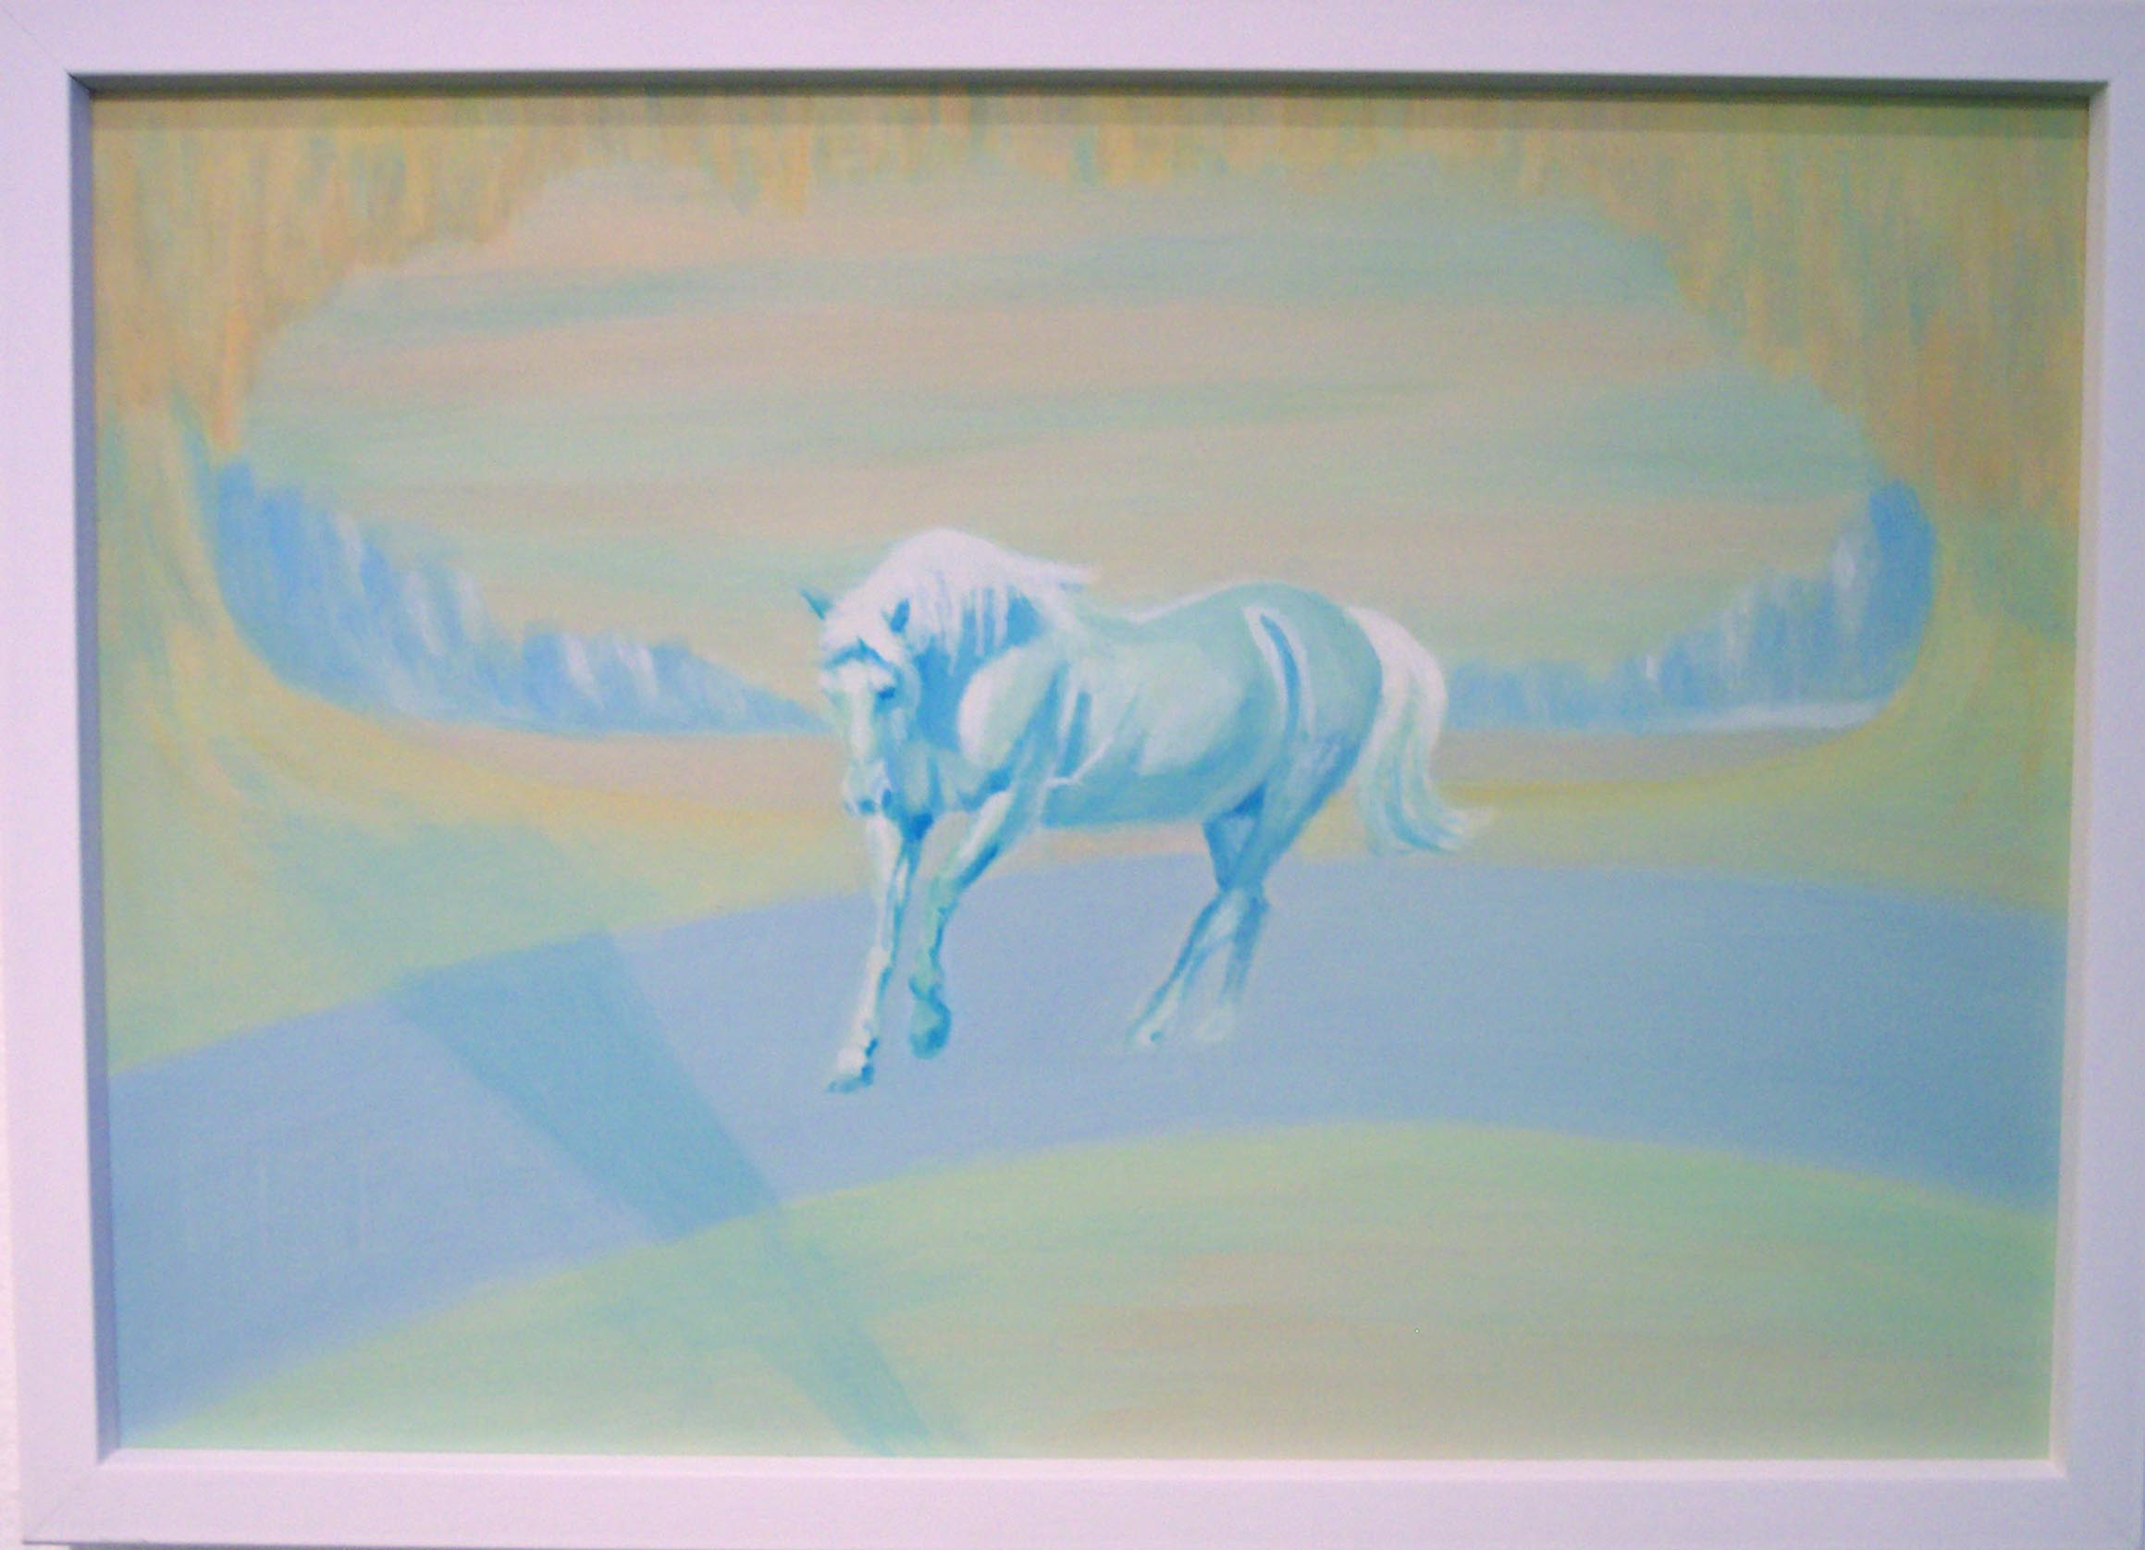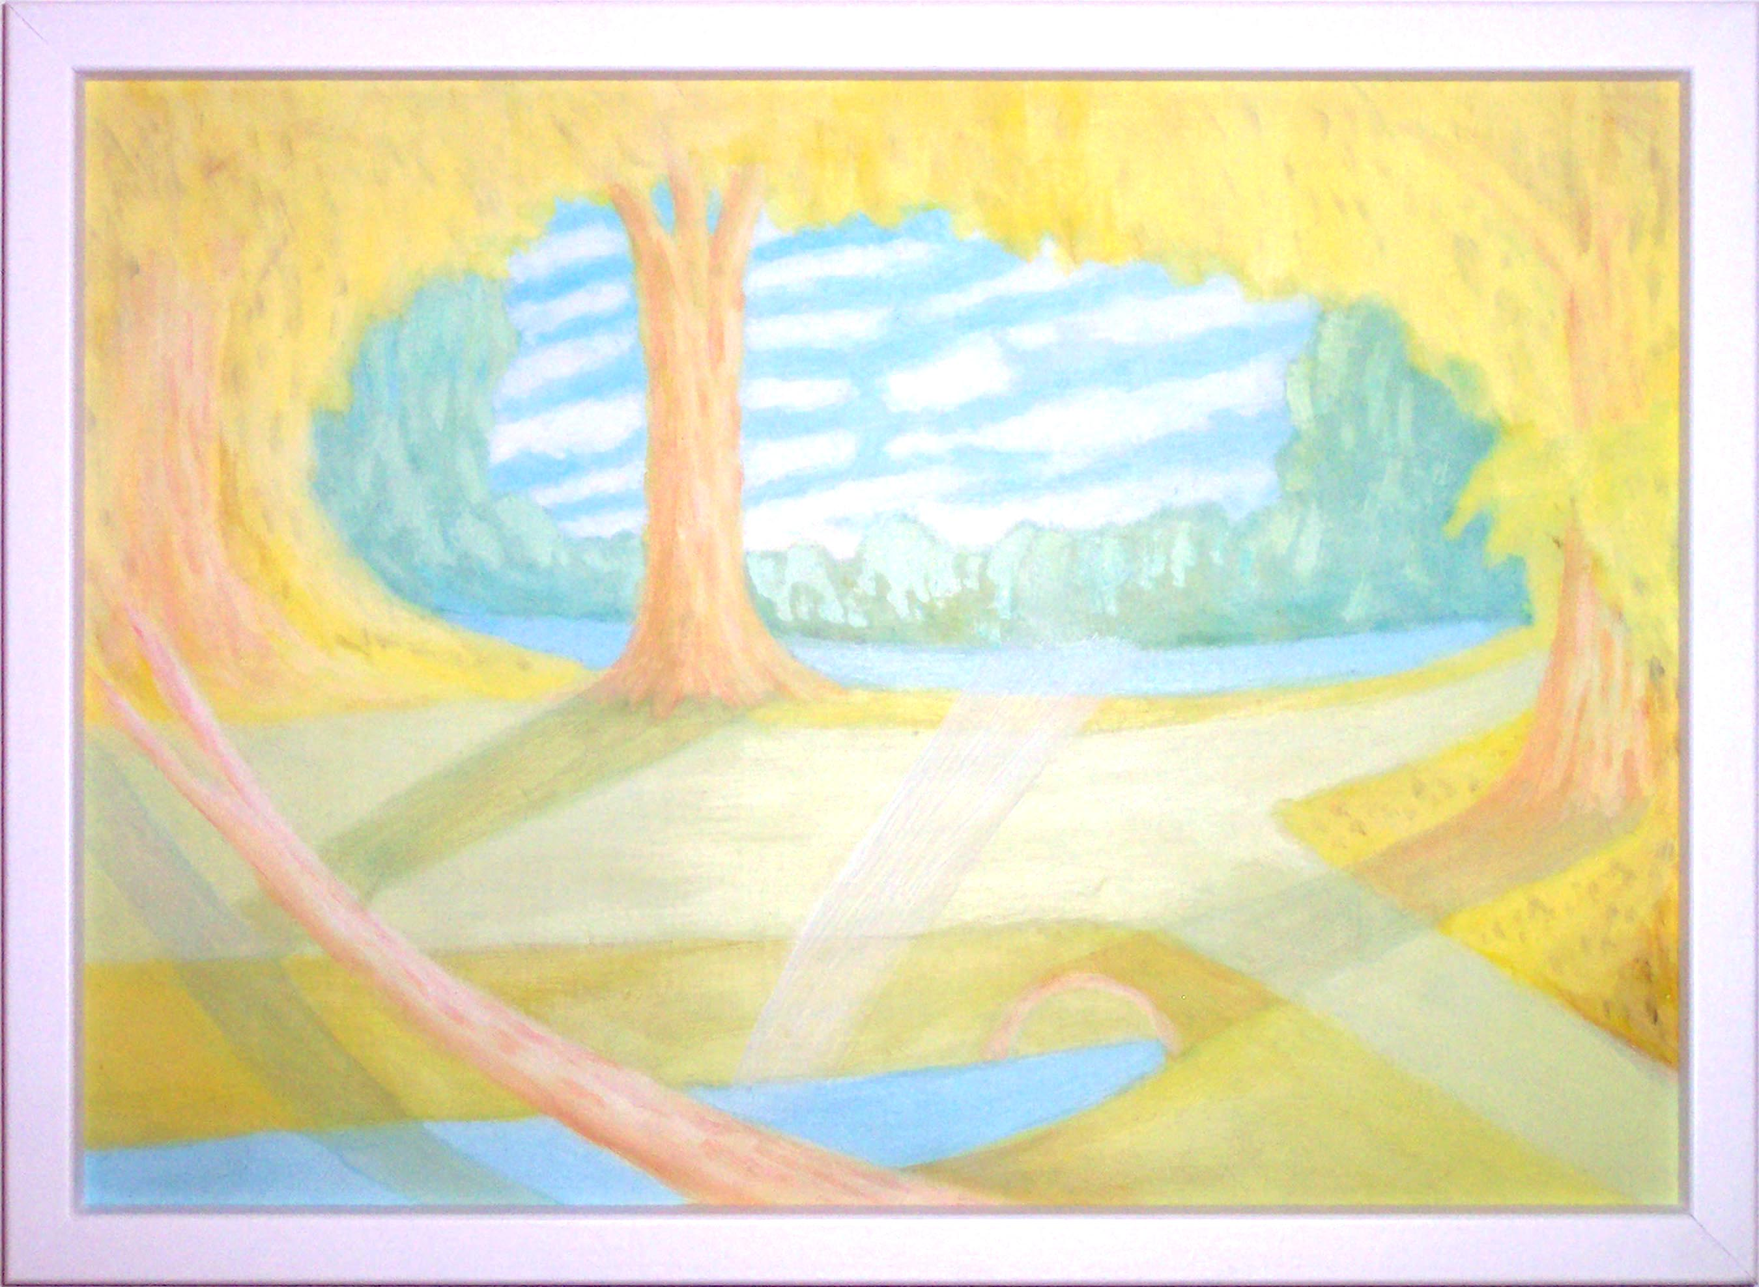

The Jack Hanley Gallery, San Francisco is pleased to present the first American solo show by New Zealand-based painter Saskia Leek, featuring 16 new works.

Saskia Leek began exhibiting her paintings in the early 1990s, and her subject matter is drawn from her real and imagined memories of growing up in Christchurch. Her naïve, almost childlike style established her reputation as an artist who was willing to question accepted principles of ‘good painting’. Initially the works appear crude and amateurish; her naïve style is often absent of scale and perspective. Leek’s choice of media, acrylic on board, as well as the flatness with which she depicts her subject matter evokes a second-hand quality. The works are all uniform in size but each work creates a world unto itself - making each painting wholly different from the group.
The essentially feminine subject matter in this series of work elicits strong nostalgic responses. The scenes remain anonymous and mostly vacant but suggest things from Leek’s past, both real and imaginary – pastoral houses, galloping horses, and crystallized landscapes; things left behind but not forgotten. Her bleached palette even recalls the faded colors of memory - pastel yellows, faint blues, washed out greens and hazy pinks.
Saskia Leek has shown widely in New Zealand and in 2004 was part of the exhibition entitled Some Forgotten Place at the Berkeley Art Museum.
For more information or images, please contact Ava Jancar at: (415)522-1623, or visit our website at: www.jackhanley.com.

