November 18, 2005

FOR IMMEDIATE RELEASE

Tasha Amini
November 26th – January 1, 2006
Opening reception: Saturday, November 26th, 6 – 9pm

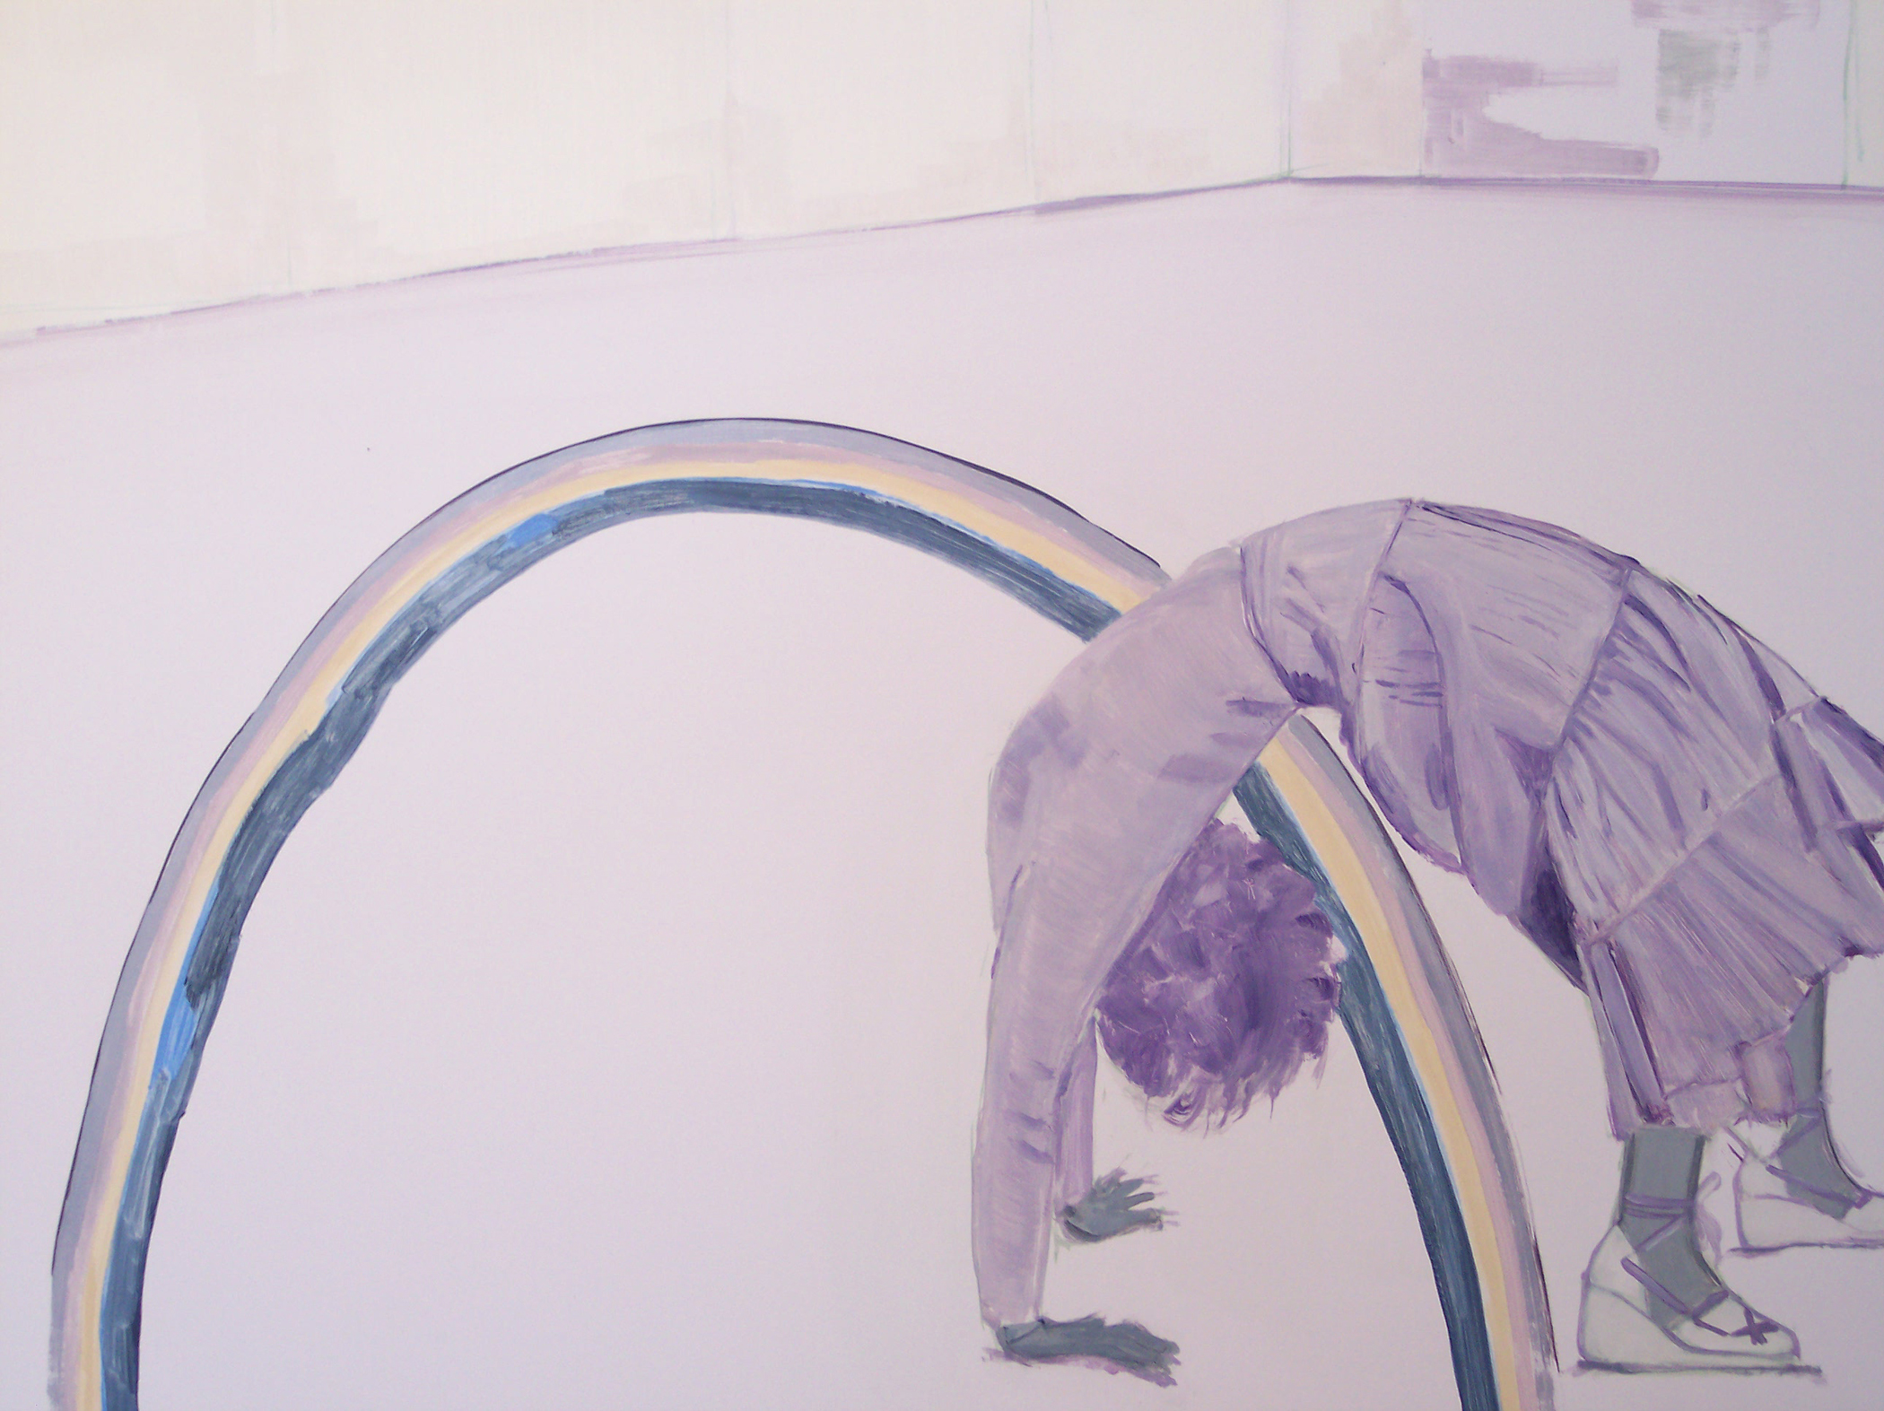

The Jack Hanley Gallery in Los Angeles is pleased to present the first American solo exhibition by London-based painter Tasha Amini.

Simultaneously evoking classical painting and psychedelia, Amini interweaves female figures into surreal landscapes through a series of interlocking narratives that are only partially revealed, with specific details missing or rubbed out. Often overlaid with enigmatic props such as ribbons, rainbows and sashes, the figures appear obscured or detached; but there is an obvious tenderness in her portraits that feels at times both lyrical and melancholy.
Amini uses photographs only as a starting point for her works as they are quickly transformed by her deliberately limited palette.

Her work has been exhibited in London at the Kate MacGarry Gallery.

For more information or images please contact Ava Jancar at 415.522.1623 or at info@jackhanley.com.

